Overview
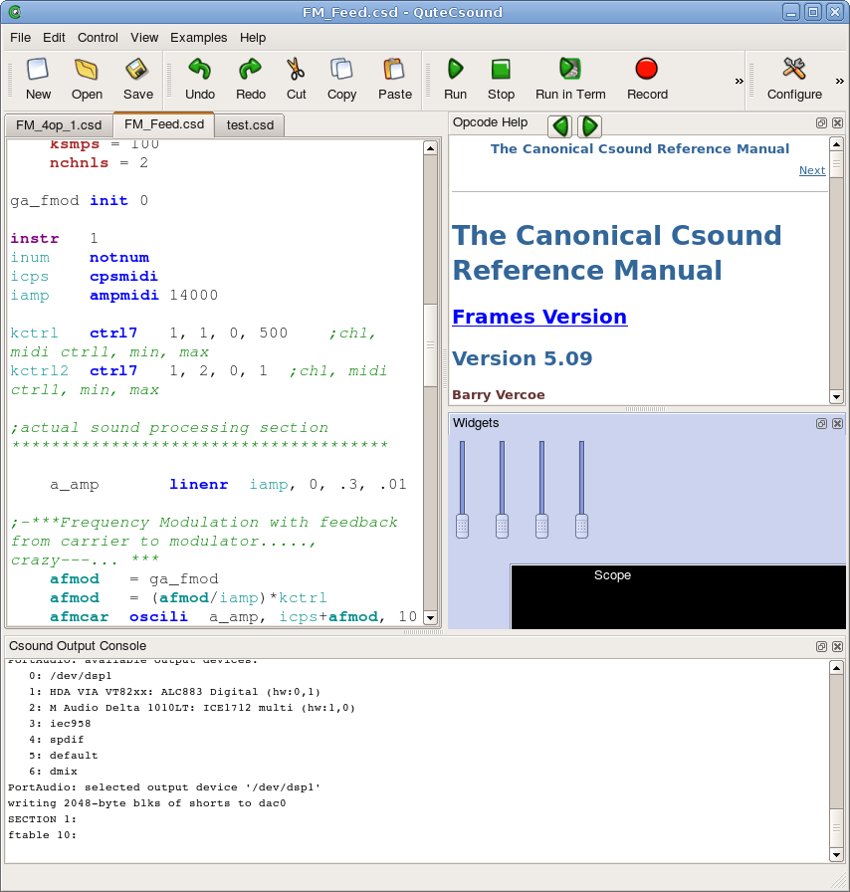
Detachable Toolbars
Detachable help panel with back and forward buttons, which can display opcode help entries and other important reference documents like GEN routines overview.

Detachable widget panel for realtime interaction with Csound. Widgets can be edited graphically and are saved in a special section of the csd which is hidden by QuteCsound
Detachable console panel which displays Csound's output. There is also a convenient Console Widget which can be created inside the widget panel
Code Editor with syntax highlighting and autocompletion
Multiple files can be open simutaneously in tabs.

File operations
New | CTRL+N | Create new untitled file
Open | CTRL+O | Open existing file
Save | CTRL+S | Save current file
Save as |  | Save current file as a different file
Reload |  | Revert file to last saved version
Close current tab | CTRL+W | Close current file
Exit | CTRL+W | Exit QuteCsound

Editor Panel
Undo | CTRL+Z | Undo last change
Redo | SHIFT+CTRL+Z | Redo change
Cut | CTRL+X | Cut selected text
Copy | CTRL+C | Copy selected text to clipboard
Paste | CTRL+V | Paste clipboard in current cursor position
Find and replace | CTRL+F | Open find and replace dialog
Auto Complete | ALT+C | Auto complete opcode, see status bar for active completion
Comment | CTRL+D | Comment selected text (adds ';' character before each line)
Uncomment | SHIFT+CTRL+D | Uncomment selected text (removes ';' character at the start of each line)
Indent | CTRL+I | Indent selection (add Tab to each line)
Unindent | SHIFT+CTRL+I | Unindent selection (remove Tab from the start of each line)
Join orc/sco |  | Opens dialog for joining open orc and sco files into a new csd file.
Show opcode entry | SHIFT+F1 | Opens opcode entry for opcode under cursor in help panel and show help panel if hidden
Show opcode entry in external browser | ALT+SHIFT+F1 | Opens opcode entry for opcode under cursor in external browser
Opcode selection | RIGHT CLICK | From the context menu, the Opcodes menu allows selection of opcodes by category.

Widget Panel
Cut | CTRL+X | Cuts selected widgets
Copy | CTRL+C | Copies selected widgets to clipboard
Paste | CTRL+V | Pastes widgets in clipboard
Duplicate | CTRL+D | Duplicates selected widgets
Widget Edit Mode | CTRL+E | Activates edit mode for widget panel

Control
Run | CTRL+R | Run csd in realtime
Run in terminal |  | Run csound in external shell
Record |  | Start recording Csound's output to disk. Files are named sequentially in the original csd directory.
Render to file | ALT+F | Generate output to file
Edit AudioFile |  | Edit last audio file in external editor
Play Audiofile |  | Play generated audio file in external player

View
Widgets | ALT+1 | Toggle Widget Panel visibility
Help Panel | ALT+2 | Toggle Help Panel visibility
Output Console | ALT+3 | Toggle Output console Panel visibility
Utilities | ALT+4 | Open Utilities dialog

Help Panel
Back | CTRL+LEFT ARROW | Go back in help browser history
Forward | CTRL+RIGHT ARROW | Go back in help browser history
Opcode Overview | HELP MENU | Show opcode overview in help panel
GEN routines | HELP MENU | Show GEN routines overview in help panel

On OS X, substitute CTRL key for COMMAND key and ALT for OPTION key.

Configuration Dialog (Run tab)
Buffer Size (-b) | Sets the -b flag for Csound to set the software buffer size
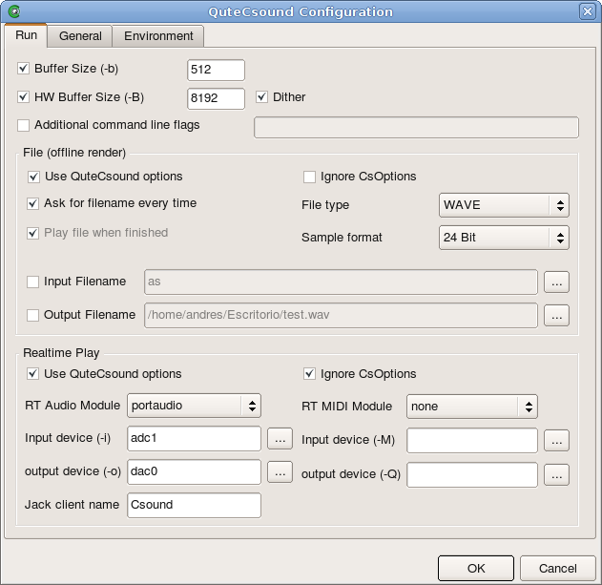  HW Buffer Size (-B) | Sets the -B flag for Csound to set the HW buffer size
Dither | Activates dither for Csound output.
Additional command line flags | Allows setting command line flags for Csound directly
File (offline render)
Use QuteCsound options | Passes the options inside this box to Csound when running offine
Ignore CsOptions | Tells Csound to ignore CsOptions inside the csd file when running offline
Ask for filename every time | QuteCsound will ask for render output filename every time
File Type | Select Output file type from the list
Sample format | Select Output file sample format from the list
Input Filename | Specify name of audio input file (-i flag)
Output Filename | Specify name of audio output file (-o flag)
Realtime Play
Use QuteCsound options | Passes the options inside this box to Csound when running in real time
Ignore CsOptions | Tells Csound to ignore CsOptions inside the csd file when running in real time
RT Audio Module | Select audio output module (varies according to platform)
Input and Output Devices (MIDI and Audio) | Type name or number for input/output device or click on browse button for a list of available devices
Jack client name | Name Csound takes when connecting to Jack (only useful if RT audio module is jack). If left blank, the default name is used.

Configuration Dialog (General tab)
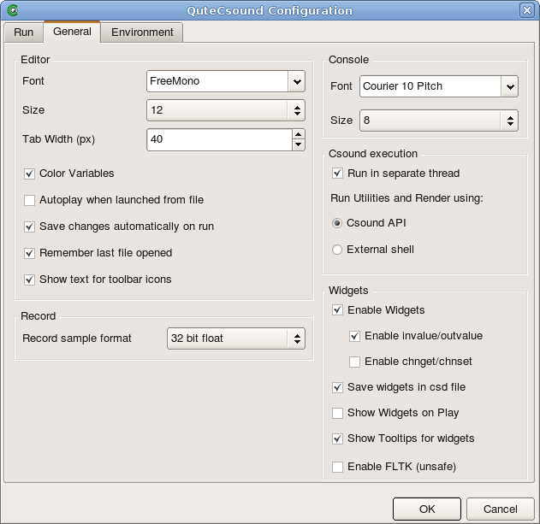
Editor
Font | Selects Text Editor Font
Size | Selects Text Editor Font Size
Tab Width (px) | Number of pixels for each tab
Color Variables | Selects whether variables have color highlighting
Autoplay | Selects whether csd's are autoplayed when opened from the Desktop.
Save changes automatically on Run | Selects whether QuteCsound saves changes made to a file or the widgets whenever the file is run.
Remember last file opened | Selects whether QuteCsound recalls files open in previous session.
Show text for toolbar icons | Selects whether the text for icons in the toolbar is displayed
Console
Font | Selects Console Dock widget's font
Size | Selects Console Dock widget's font size
Csound Execution
Run in separate thread | Selects whether Csound is run in QuteCsound's thread or in a separate thread when using the API
Run Utilities and Render Using | Selects whether to use the API or an external shell when rendering to file and running utilities.
Widgets
Enable Widgets | Selects whether widgets are enabled
Enable invalue/outvalue | Selects whether widgets interact with Csound through invalue and outvalue opcodes
Enable chnget/chnset | Selects whether widgets interact with Csound through chnget and chnset opcodes. It is not recommended to use both at the same time.
Save widgets on csd file | Selects whether are saved as a section of the csd file. If not checked, widgets are temporary.
Show widgets on play | Selects whether widgets are shown when Csound is run
Show tooltips | Selects whether tooltips displaying widget's channel are shown
Enable FLTK | Enables FLTK when using the API. (FLTK is always available when running in external shell.

Configuration Dialog (Environment tab)

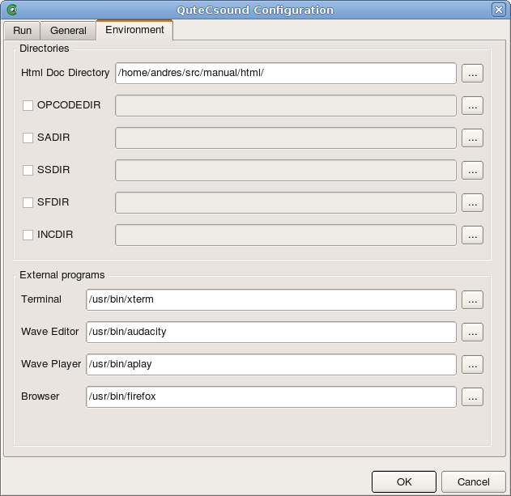
Directories
Html Doc Directory | Full path to the Csound html documentation. This is needed for the help panel to display the manual.
OPCODEDIR | Sets the OPCODEDIR environment variable only within QuteCsound
SADIR | Sets the SADIR environment variable only within QuteCsound
SSDIR | Sets the SSDIR environment variable only within QuteCsound
SFDIR | Sets the SFDIR environment variable only within QuteCsound
INCDIR | Sets the INCDIR environment variable only within QuteCsound
External Programs
Terminal | Selects the external shell used by QuteCsound to run Csound externally.
Wave Editor | Selects the external editor called by QuteCsound for rendered or recorded audiofiles.
Wave Player | Selects the external player called by QuteCsound for rendered or recorded audiofiles.
Browser | Selects the external browser to be used for documentation.

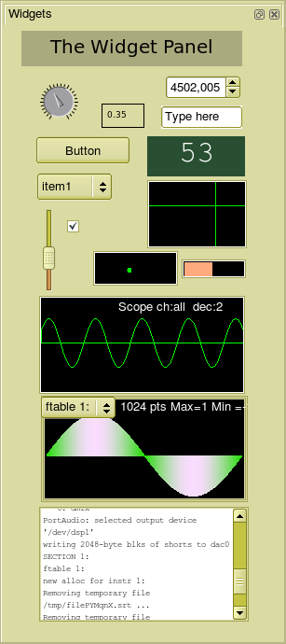
Widget Overview
Label

Knob
Buttons can transmit values but can also generate score events
Menu
Checkbox
Slider
The scope widget is an oscilloscope for any or all channels of Csound's output
Console widget
Spin Box
Line Edit widgets accept text strings
Scroll Number widgets change their value when dragged with the mouse
Controller widgets offer mutiple types of mouse control
Graph widgets show Csound ftables and can show spectrum with the dispfft opcode
Display widgets can show values from Csound
The color of the widget panel's background can be set.
To create a widget, right-click anywhere on the widget panel (without a widget) and select the type of widget you want to create

To change a widget's properties, right-click on it and select “Properties”

To delete a widget, right click on a widget and select “Delete” from the menu

To enter or leave edit mode press Ctrl+E or Command+E on OS X.

